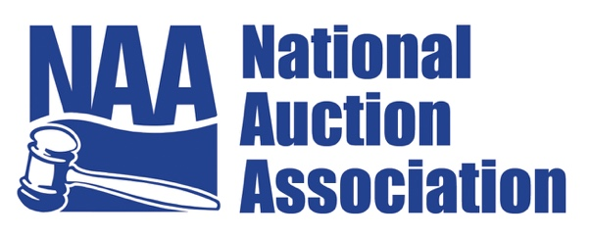

**July 26, 2024**

**For Immediate Release**

**National Auction Association Announces 2024 Champions, Hall of Fame Inductees, and New President**

**Pittsburgh, PA – July 26, 2024** – The National Auction Association (NAA) is thrilled to announce the winners of the 2024 International Auctioneer Championship (IAC), the International Junior Auctioneers Championship (IJAC), and the newly elected president, along with the latest inductees into the NAA Hall of Fame. These announcements were made during the NAA's annual Conference & Show, celebrating excellence, leadership, and innovation in the auction industry.

**IAC Champions: Shane McCarrell and Marcela Davila**

Shane McCarrell from Clarksville, Tennessee, emerged as the overall champion of the 2024 IAC. A graduate of Nashville Auction School and Past President of the Tennessee Auctioneers Association, Shane captivated the judges and audience with his exceptional skills and charismatic presence. Reflecting on his journey, Shane shared how the auction industry saved his life after his military career ended, providing him with purpose and direction.

Marcela Davila, a native of Mexico and a graduate of the World Wide College of Auctioneering, won the Women's Division of the IAC. She looks forward to expanding the International within the NAA, “I feel like the worldwide presence of the Association will help us create a stronger voice as a global profession, and aid auctioneers around the world to better build their businesses in their own countries like I did by taking advantage of the incredibly valuable resources offered by the NAA, including Education and the Community that has helped me grow so much as a professional”

**IJAC Champion: Caleb Taylor**

Caleb Taylor was named the 2024 IJAC champion. Inspired by his father, Caleb entered the auction industry and quickly made his mark. He highlighted the comradery and supportive environment of the IJAC, noting the invaluable friendships and mentorships he gained. Caleb is excited to contribute to the expansion of the NextGen Program and promote the auction industry among young professionals.

**Newly Elected NAA President: John Schultz**

John Schultz, AMM, has been unanimously elected as the President of the NAA. With over 25 years of experience in the auction industry, John is a Partner and Chief Marketing and Technology Officer at Grafe Auction Company. His involvement with the NAA has been transformative, providing him with opportunities for professional growth, networking, and leadership development. As President, John aims to focus on technology and digital solutions, modernize educational offerings, strengthen advocacy efforts, launch a national promotional campaign, and foster greater collaboration within the auction industry.

**Hall of Fame Inductees: Scott Shuman, Jack Christie, and Jay Nitz**

The NAA proudly inducted Scott Shuman, Jack Christie, and Jay Nitz into the Hall of Fame. Established in 1961, the Hall of Fame recognizes leaders within the auction industry. Bronze-etched portrait plaques of the honorees will adorn the walls of the National Auction Museum at the NAA headquarters in Overland Park, Kansas.

For more information about the National Auction Association and its initiatives, visit [auctioneers.org](https://auctioneers.org).

The National Auction Association represents thousands of auction professionals from the U.S. and across the world. The mission of the NAA is to provide critical resources to auction professionals that will enhance their skills and successes. Founded in 1949, the NAA’s headquarters are in Overland Park, Kansas. To learn more about the auction method of marketing or find an auction or auctioneer, please visit [www.auctioneers.org](http://www.auctioneers.org).

**Contact:**

Arturo Mendoza  
National Auction Association  
amendoza@auctioneers.org  
913-563-5430